RCA
Unexpeted vm shutdown when Jenkins server running due to that the Jenkins server ggoes to stopped or deallocalted
To resolve this follow below steps .
Here's a complete, audit-ready checklist for diagnosing and resolving Jenkins startup failures after unexpected Linux VM shutdowns — especially when you see:
Job for jenkins.service failed because the control process exited with error code.

Root Cause Summary
After a sudden shutdown or crash, Linux may remount the root filesystem (including /tmp) as read-only to prevent data corruption. Jenkins needs to write to /tmp during startup. If it can't, it fails immediately.

Full Diagnostic & Recovery Steps

🔍 Step 1: Check Jenkins service status
systemctl status jenkins
Look for:
- Main PID: ... (code=exited, status=1/FAILURE)
- Start request repeated too quickly
- Failed with result 'exit-code'

🔍 Step 2: Check detailed logs
journalctl -u jenkins –xe or sudo journalctl –u Jenkins -xe
Look for:
java.io.IOException: Read-only file system
Jenkins failed to create a temporary file in /tmp

Step 3: Confirm /tmp is read-only
touch /tmp/testfile
If it fails with Read-only file system, proceed to next step.

Step 4: Check mount status
mount | grep ' / '
If you see ro, your root filesystem is read-only.

Step 5: Remount root filesystem
sudo mount -o remount,rw /
Then verify:
mount | grep ' / '
Should now show rw.

Step 6: Fix /tmp permissions
sudo chmod 1777 /tmp
ls -ld /tmp
Expected output:
drwxrwxrwt ...

Step 7: Restart Jenkins
sudo systemctl daemon-reexec
sudo systemctl daemon-reload
sudo systemctl restart jenkins

Preventive Hardening for Production

1. Configure Jenkins to use /var/tmp
Avoid dependency on /tmp:
sudo systemctl edit jenkins
Add:
[Service]
Environment="JAVA_OPTS=-Djava.io.tmpdir=/var/tmp"

2. Ensure automatic fsck on boot
Check /etc/fstab:
cat /etc/fstab
Make sure root has defaults 0 1 to enable fsck.

3. Monitor disk health
Set up alerts for:
- Disk errors
- Read-only mounts
- Failed services
Use tools like monit, systemd-analyze, or cloud-native monitoring.

📄 RCS (Root Cause & Solution) Template
- Issue: Jenkins failed to start after VM reboot.
- Root Cause: /tmp was mounted read-only due to unclean shutdown, preventing Jenkins from creating temp files.
- Solution: Remounted root filesystem as read-write, restored /tmp permissions, and restarted Jenkins.
- Preventive Fix: Configured Jenkins to use /var/tmp via systemd override to avoid future dependency on /tmp.

You can copy-paste this into your production runbook or incident response guide. I can also help you turn this into a Markdown or Confluence-ready document if needed.

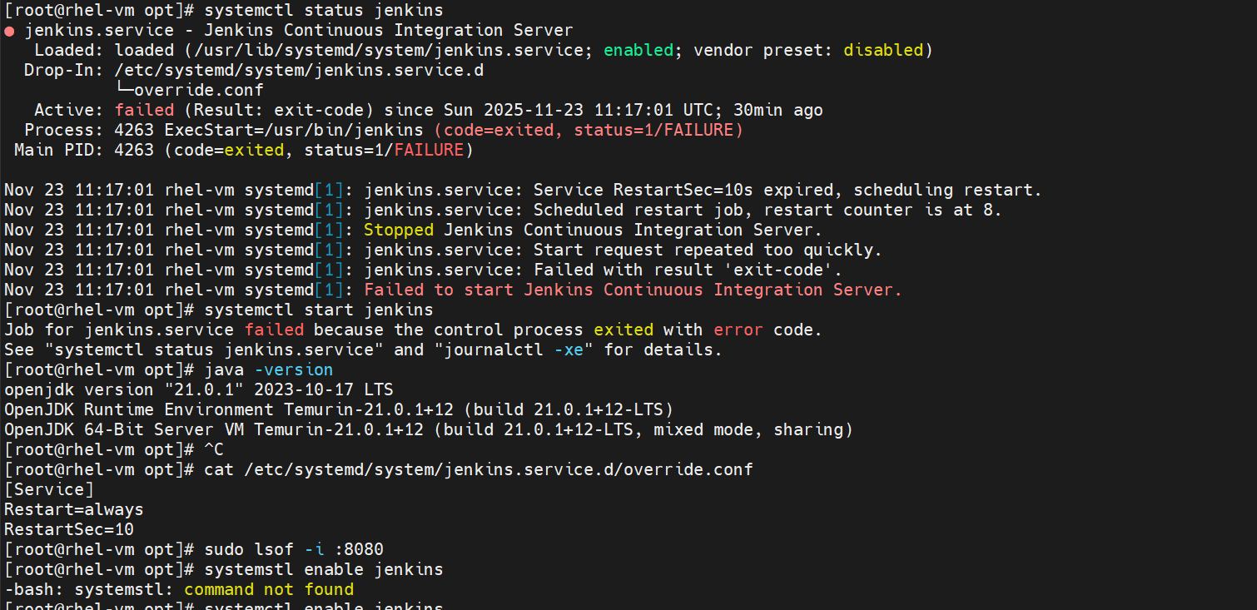

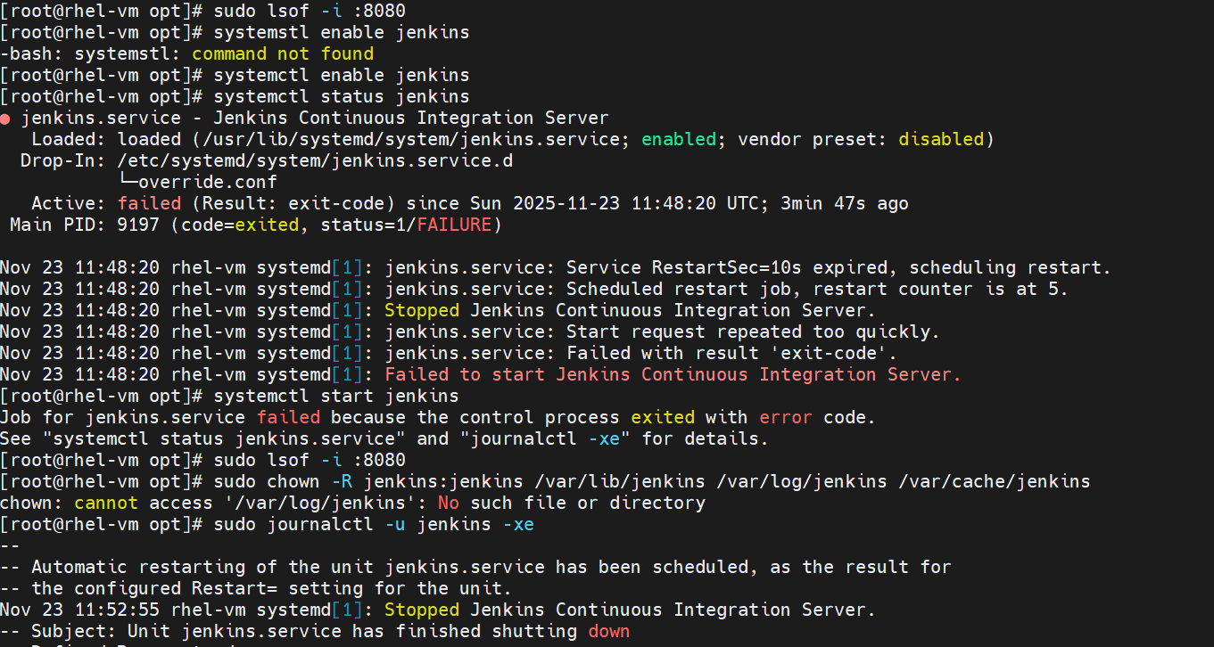

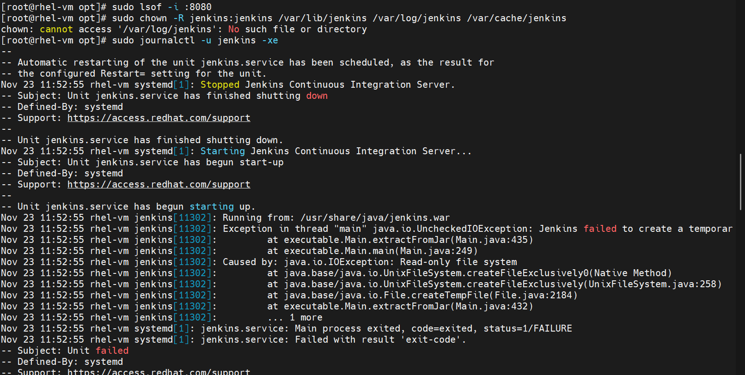

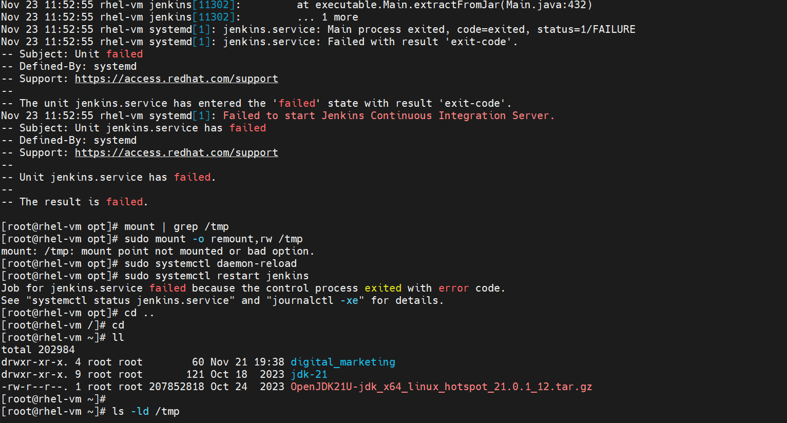
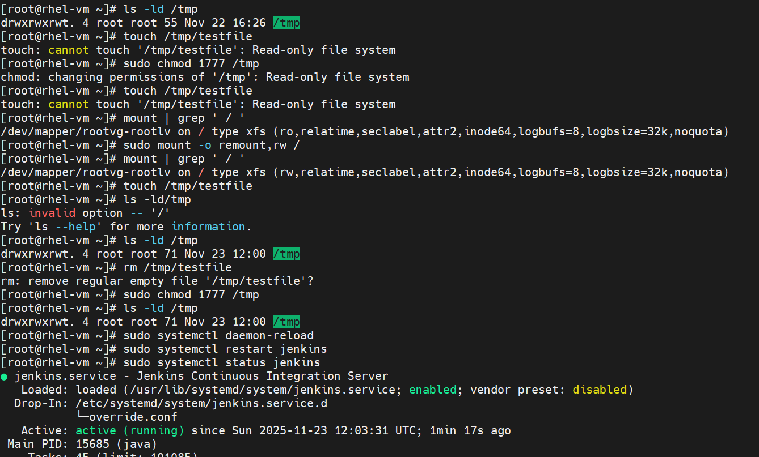
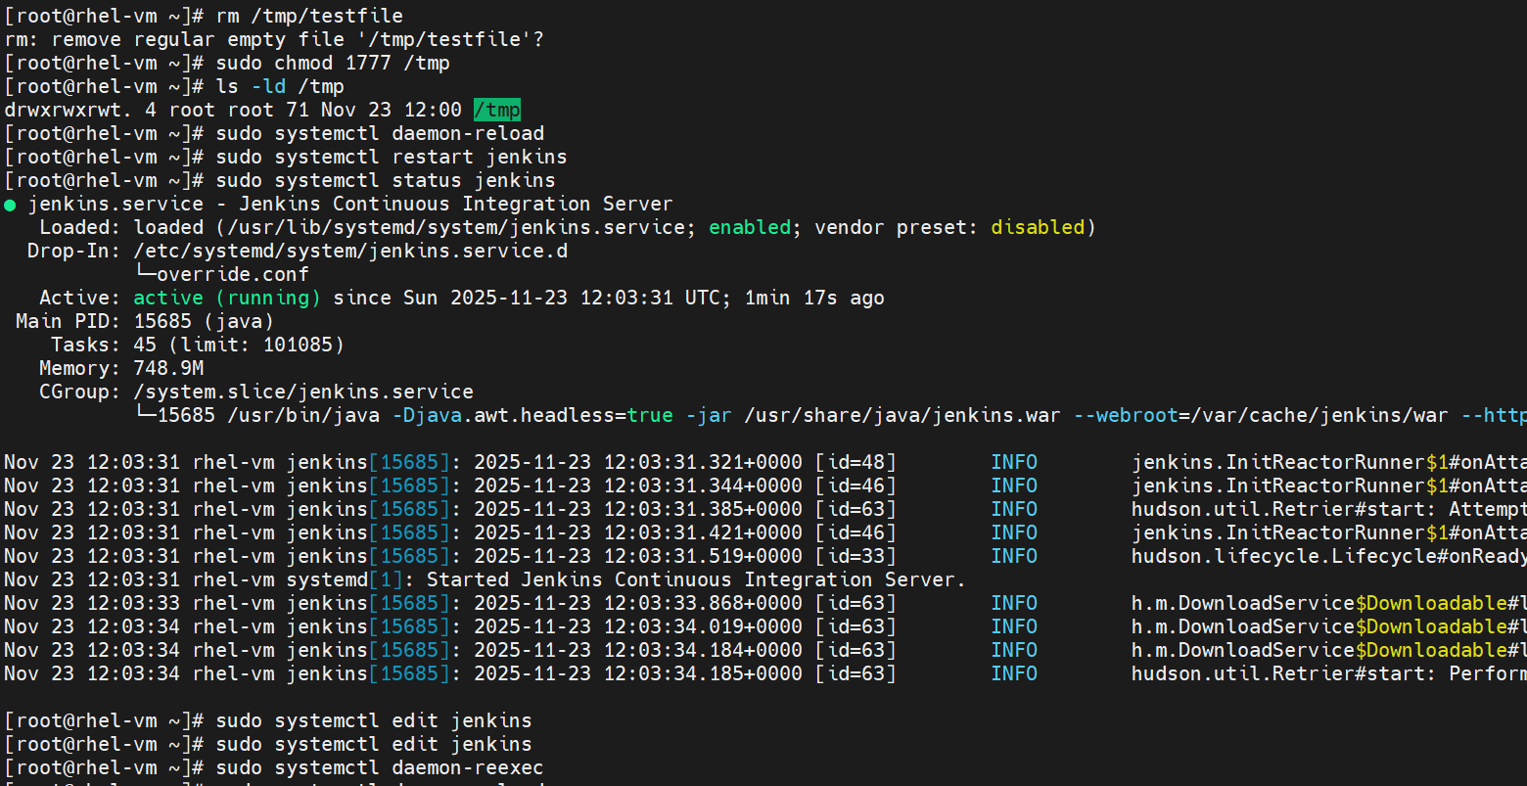
sudo systemctl edit jenkins
